Experiment-1 M. Devarajulu
14-7-2026 192212058
8-Puzzle Problem
Aim:-
To solve the 8-puzzle problem using Python Program.
Algorithm:-
- Start the program.
- Read the initial 3×3 puzzle from the user.
- Compare the input puzzle with the goal state.
- Find the position of the blank tile (0).
- Move the blank tile in all possible valid directions (up, down, left, and right) and generate new puzzle states.
- Check whether any new state matches the goal state. If it matches, display "Puzzle can be solved"; otherwise, display "Puzzle cannot be solved in one move", and stop the program.
Program (Python):-
goal = [['1','2','3'],
['4','5','6'],
['7','8','0']]

print("Enter the initial state:")
puzzle = []

for i in range(3):
puzzle.append(input().split())

# Check if already solved
if puzzle == goal:
print("Puzzle is already solved.")
else:
# Find blank space
for i in range(3):
for j in range(3):
if puzzle[i][j] == '0':
x, y = i, j

moves = [(-1,0),(1,0),(0,-1),(0,1)]
solved = False

for dx, dy in moves:
nx, ny = x + dx, y + dy

if 0 <= nx < 3 and 0 <= ny < 3:
temp = [row[:] for row in puzzle]
temp[x][y], temp[nx][ny] = temp[nx][ny], temp[x][y]

if temp == goal:
solved = True
break

if solved:
print("Puzzle can be solved in one move.")
else:
print("Puzzle is not solved in one move.")

Output:

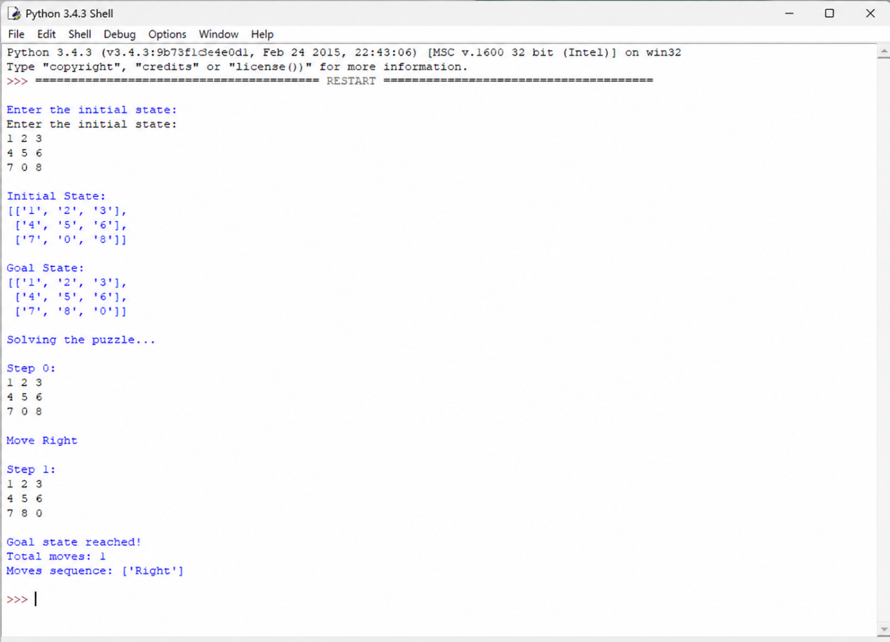

Result:
The 8-puzzle program was executed successfully. It accepted the user input, checked the puzzle state, and displayed whether the puzzle could be solved in one move.

